Brian Davis

tug75085

915409443

2 May 2020

Final Exam

**Part 1: MapReduce**

**EC2 Creation**

First, I chose the AMI type Ubuntu Server because I was able to find success setting up Hadoop on a local virtual machine running Ubuntu previously. The AMI type is seen below,



Next, I chose the instance type t2.large, which has 8 GiB of memory, in comparison to 2 GiB on the t2.micro. This is necessary in order to ensure Hadoop and MapReduce can run smoothly, as I had limited memory issues on my local environment previously. The instance type is seen below,

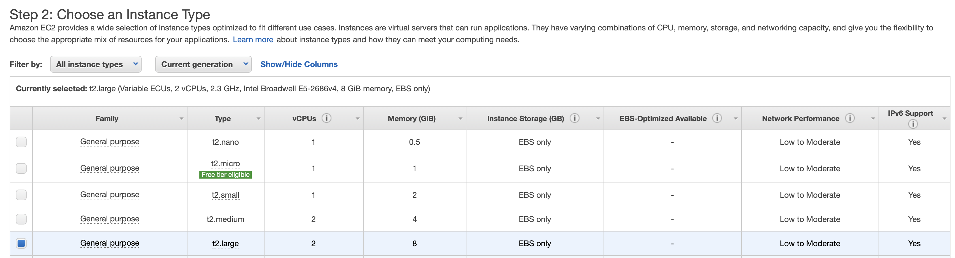

Next I created an IAM Role that allows Administrator Access to all AWS services. First I created the role, as seen below,

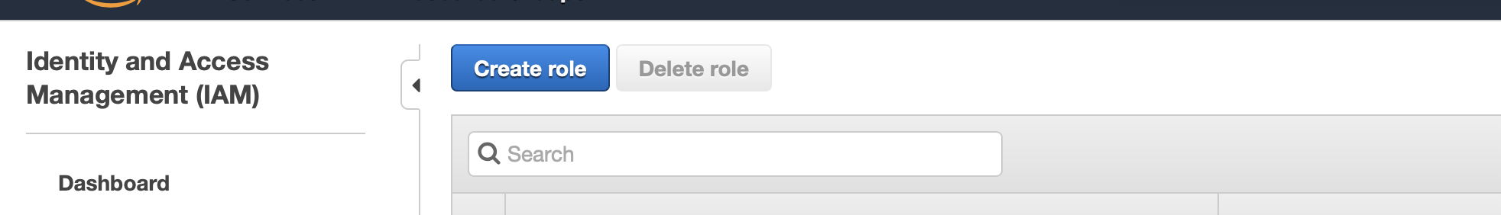

Then I selected AWS the IAM role to correspond with all AWS services.

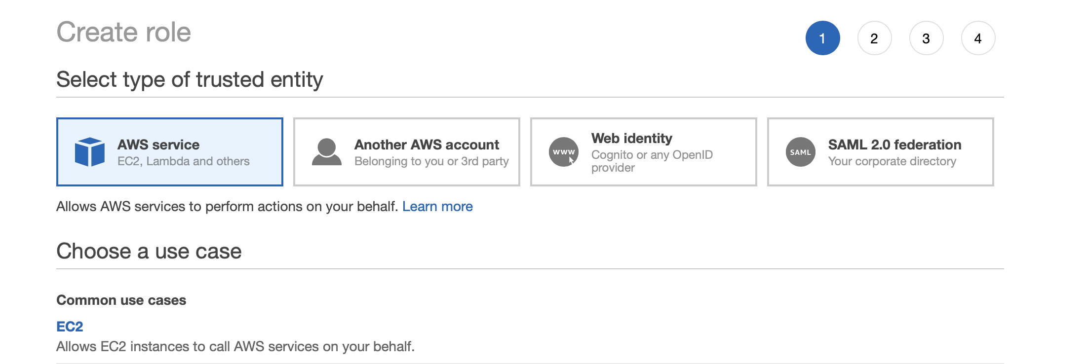

I created and named the role Administrator Access.

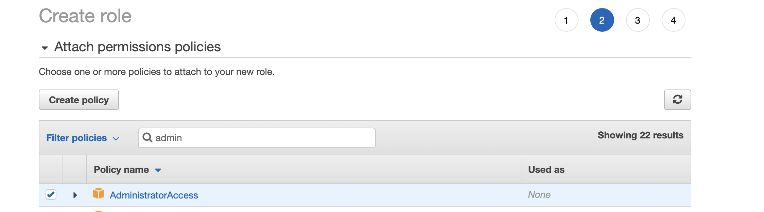

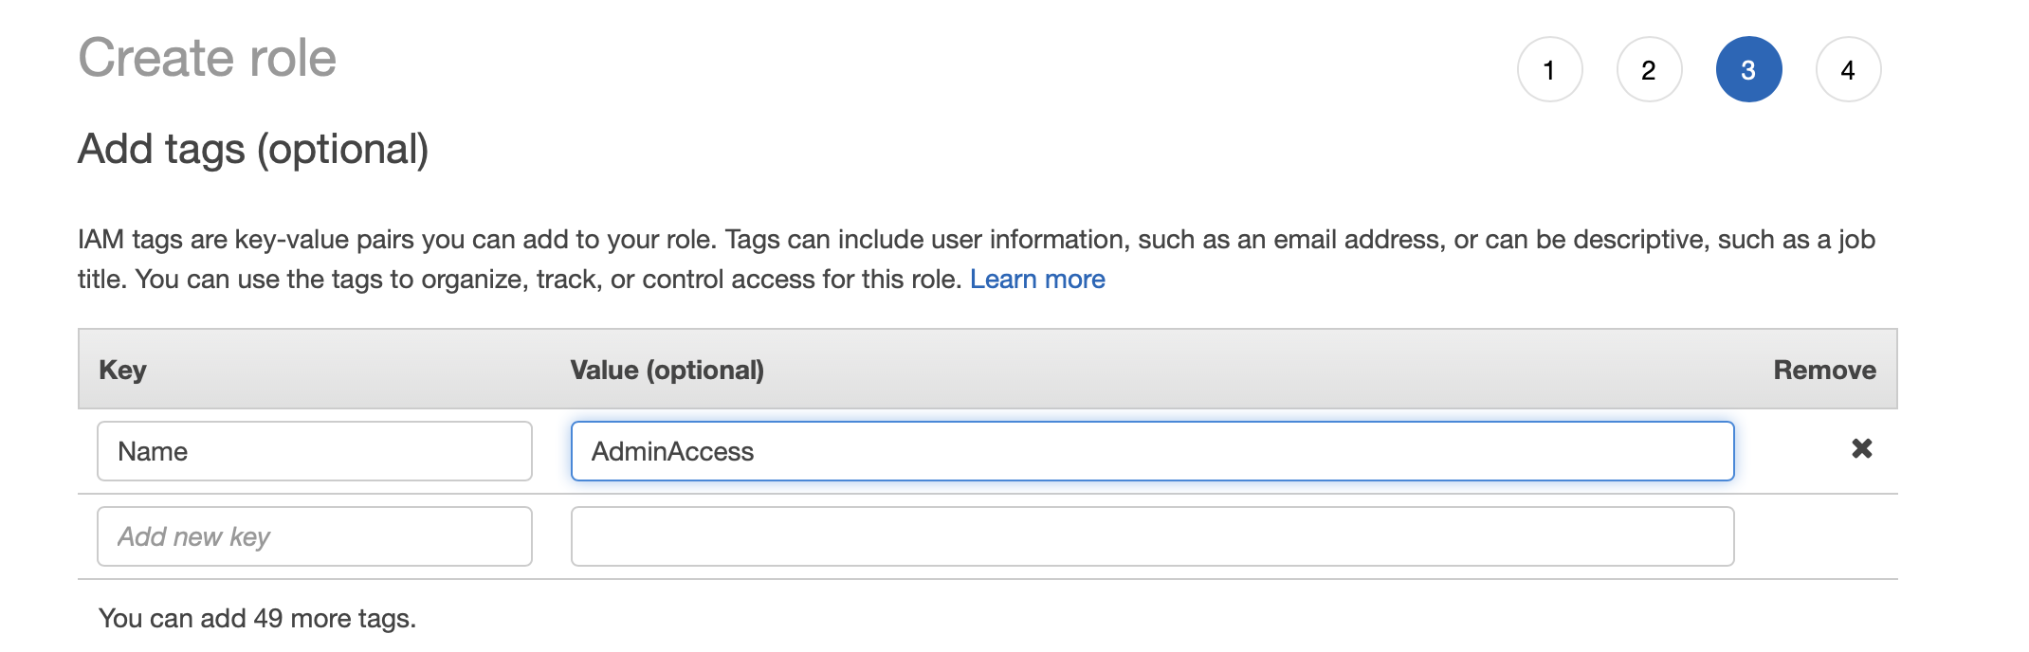

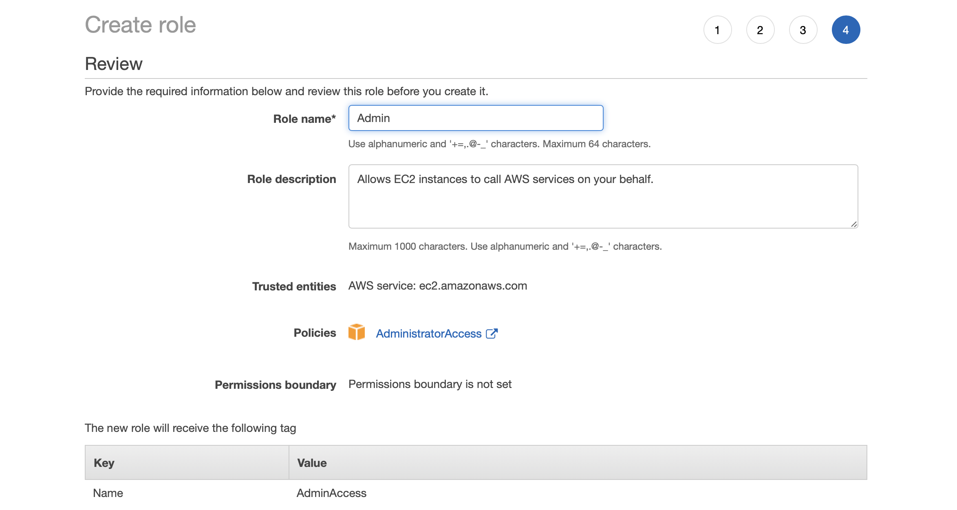

Next I selected the IAM role as a field in the Configure Instance Details of the EC2 Creation options,

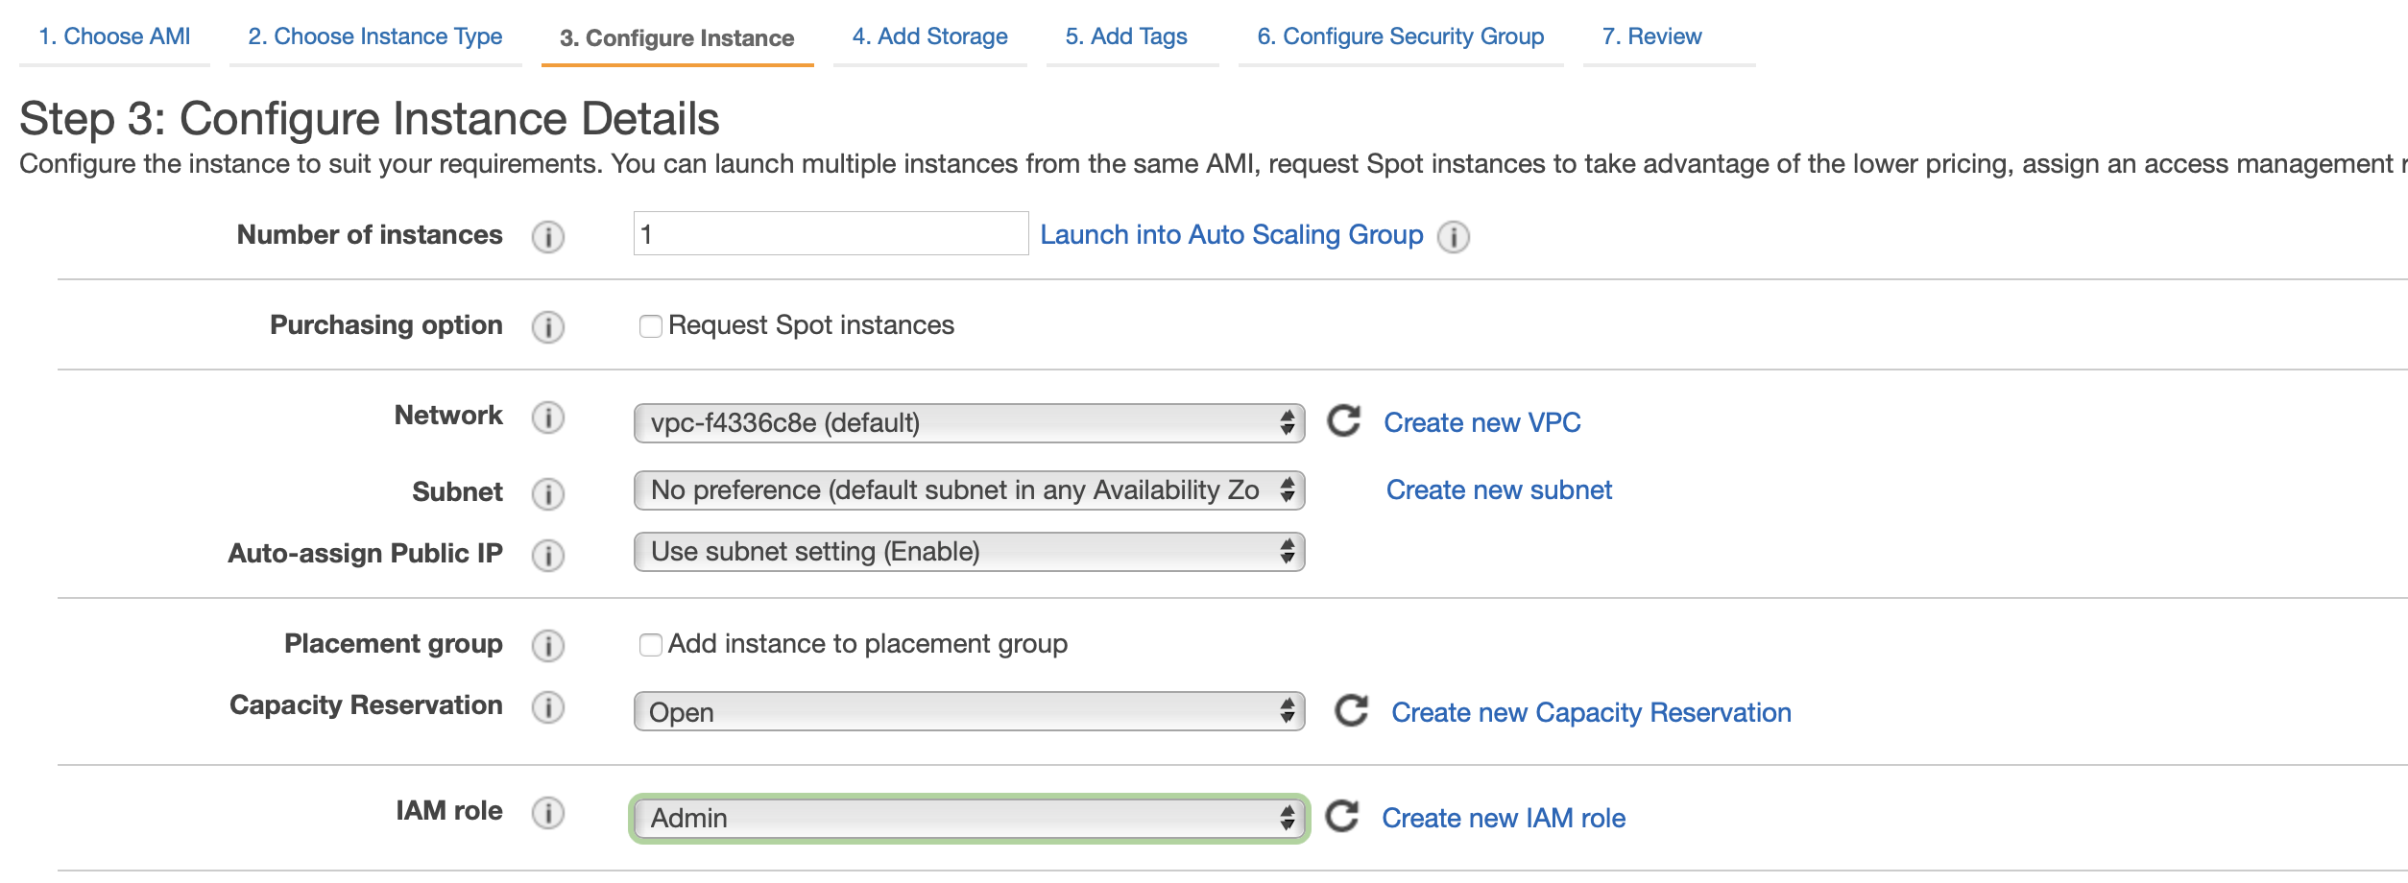

Next I gave the instance an identifier tag,

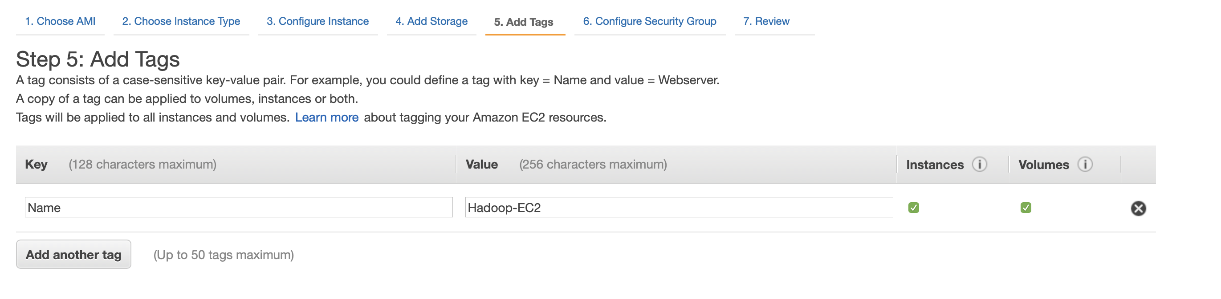

In the Configure Security Group tab of the EC2 creation, I selected all ICMP and TCP ports so that the Hadoop webserver can work properly with limited flaws, as seen below,

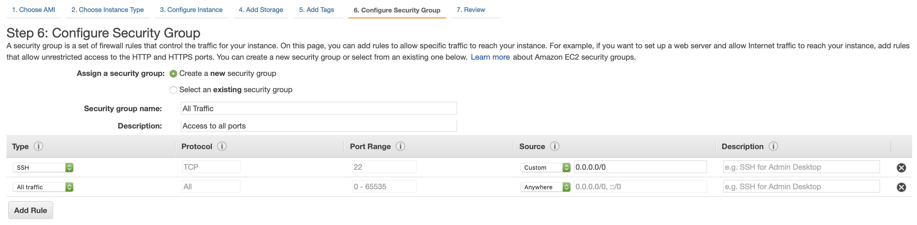

After setting all of these options, I created the EC2!

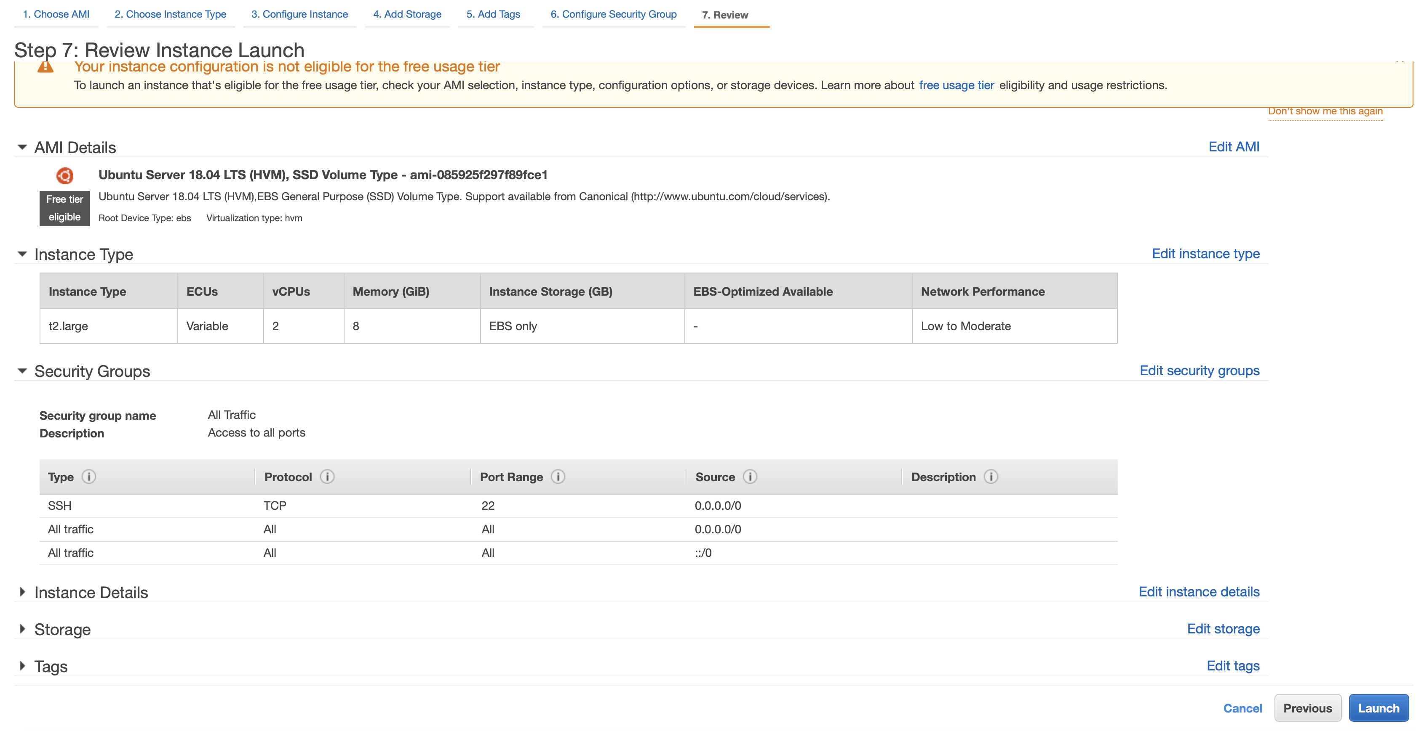

**Setting up Hadoop on Ubuntu EC2 Instance**

Now that we have our Ubuntu EC2 running, we can SSH into it,

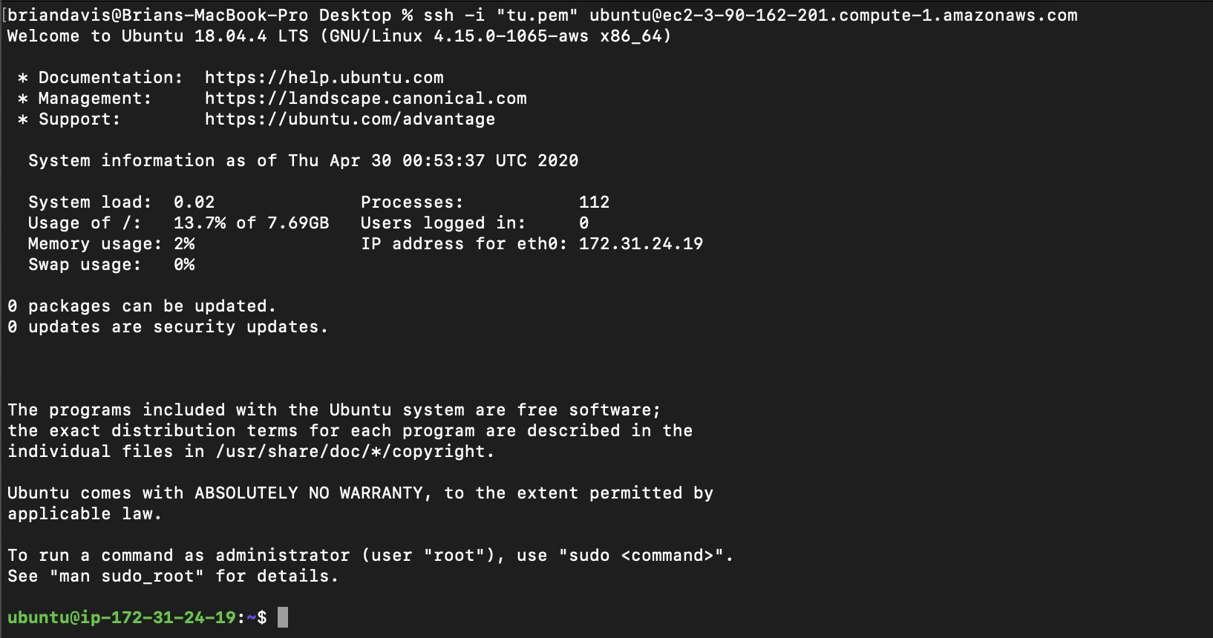

First, we must install Java and Hadoop. We gather the tar files and untar them as seen below,



First, we have to set environment variables in the ~/.bashrc, as seen below,

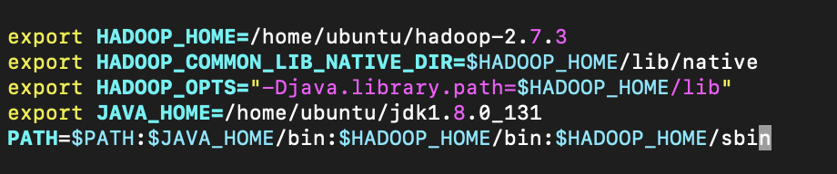

Next check that the Java and Hadoop libraries can be found,

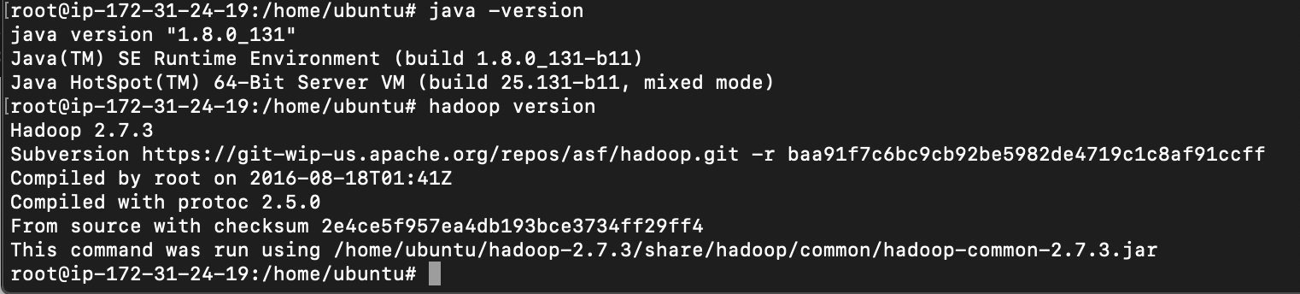

Next we activate the environment,



Then we ensure that ssh permissions for localhost are authorized,

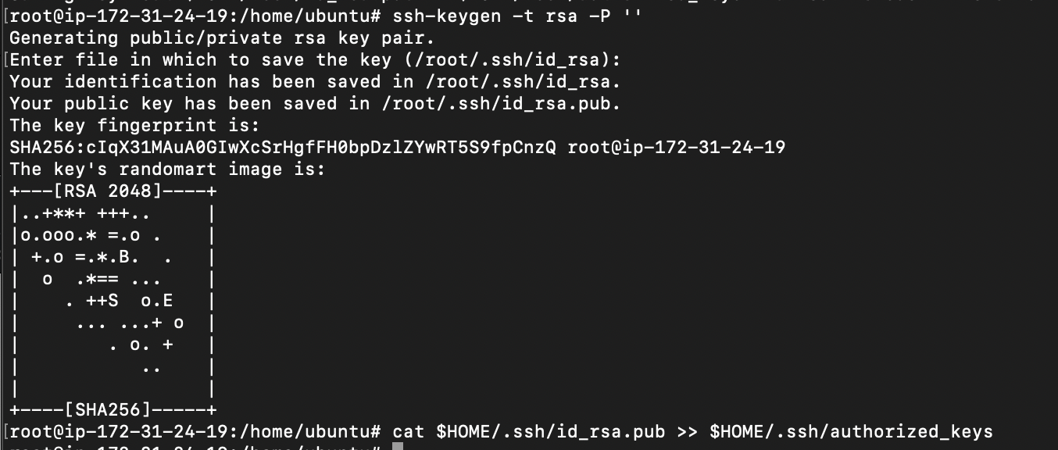

Example of ssh-ing into localhost and subsequently exiting,

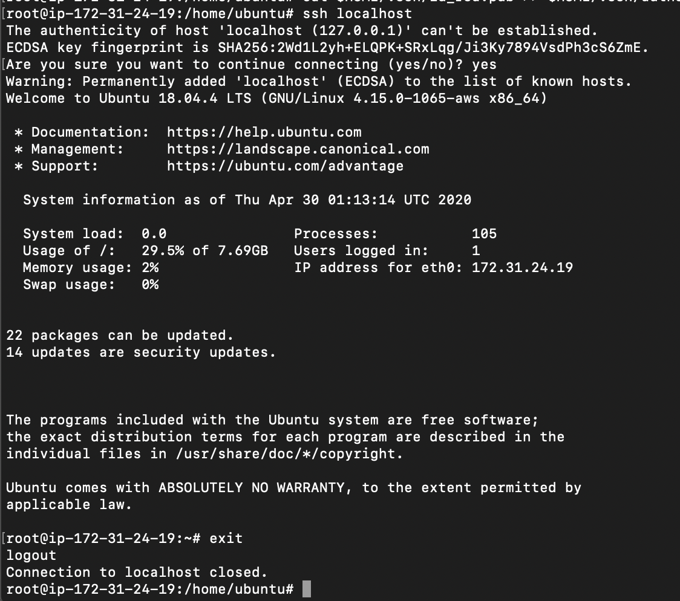

Next we must make the following modifications to the Hadoop XML and sh files in order to successfully execute tasks on the Hadoop file system.

Core-site.xml

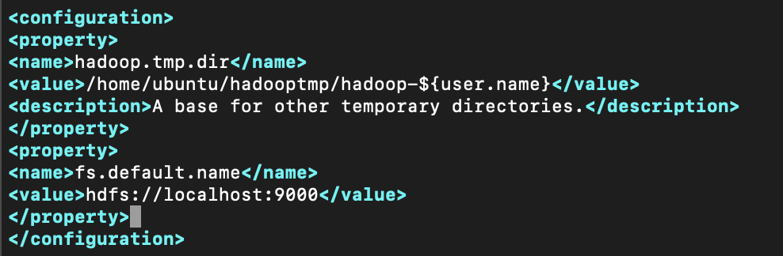

Hadoop-env.sh

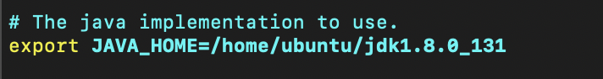

Mapred-site.xml

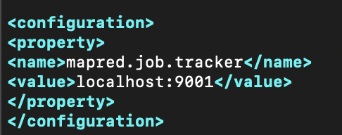

Yarn-site.xml

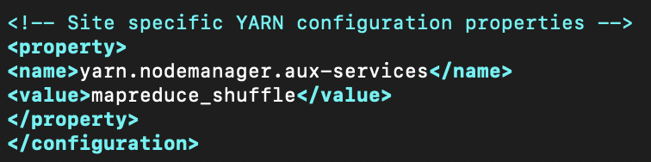

Hdfs-site.xml

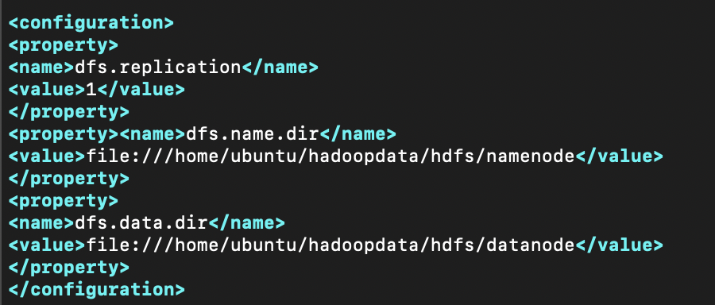

After editing all of the files (as seen finished below), we can now move on to working on Hadoop,

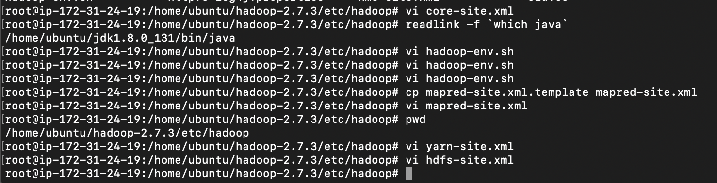

First, we format the Hadoop filesystem,

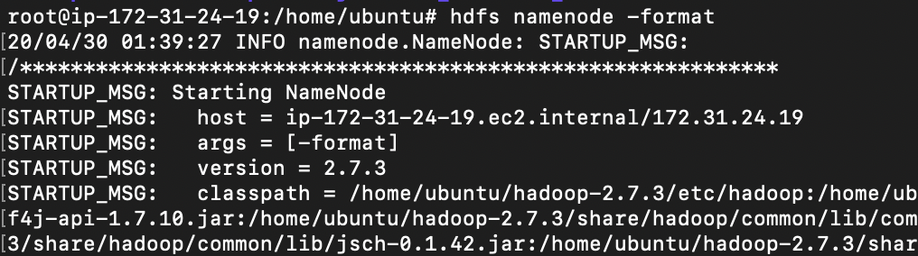

Starting the NameNode, DataNode, SecondaryNameNode,

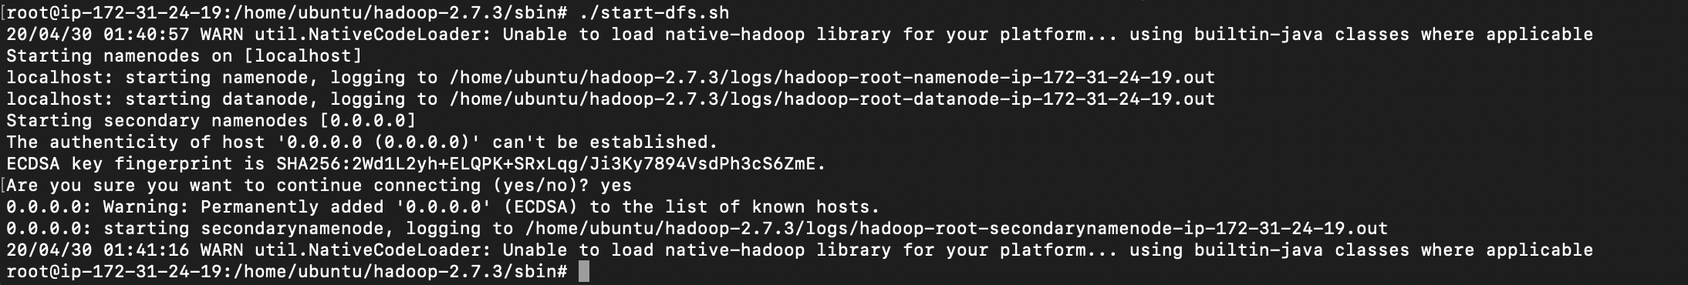

Starting the ResourceManager and NodeManager,



Starting the Mr-JobHistoryServer,



Checking to see if all of the resources are activated,

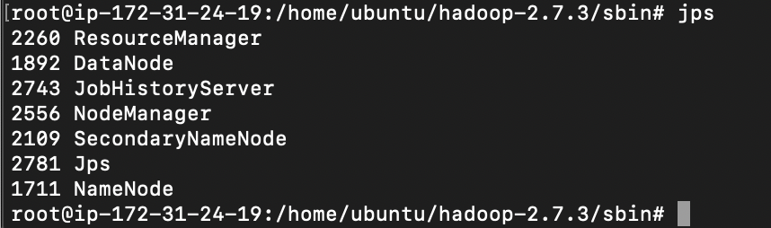

Viewing the website that displays the Hadoop file system

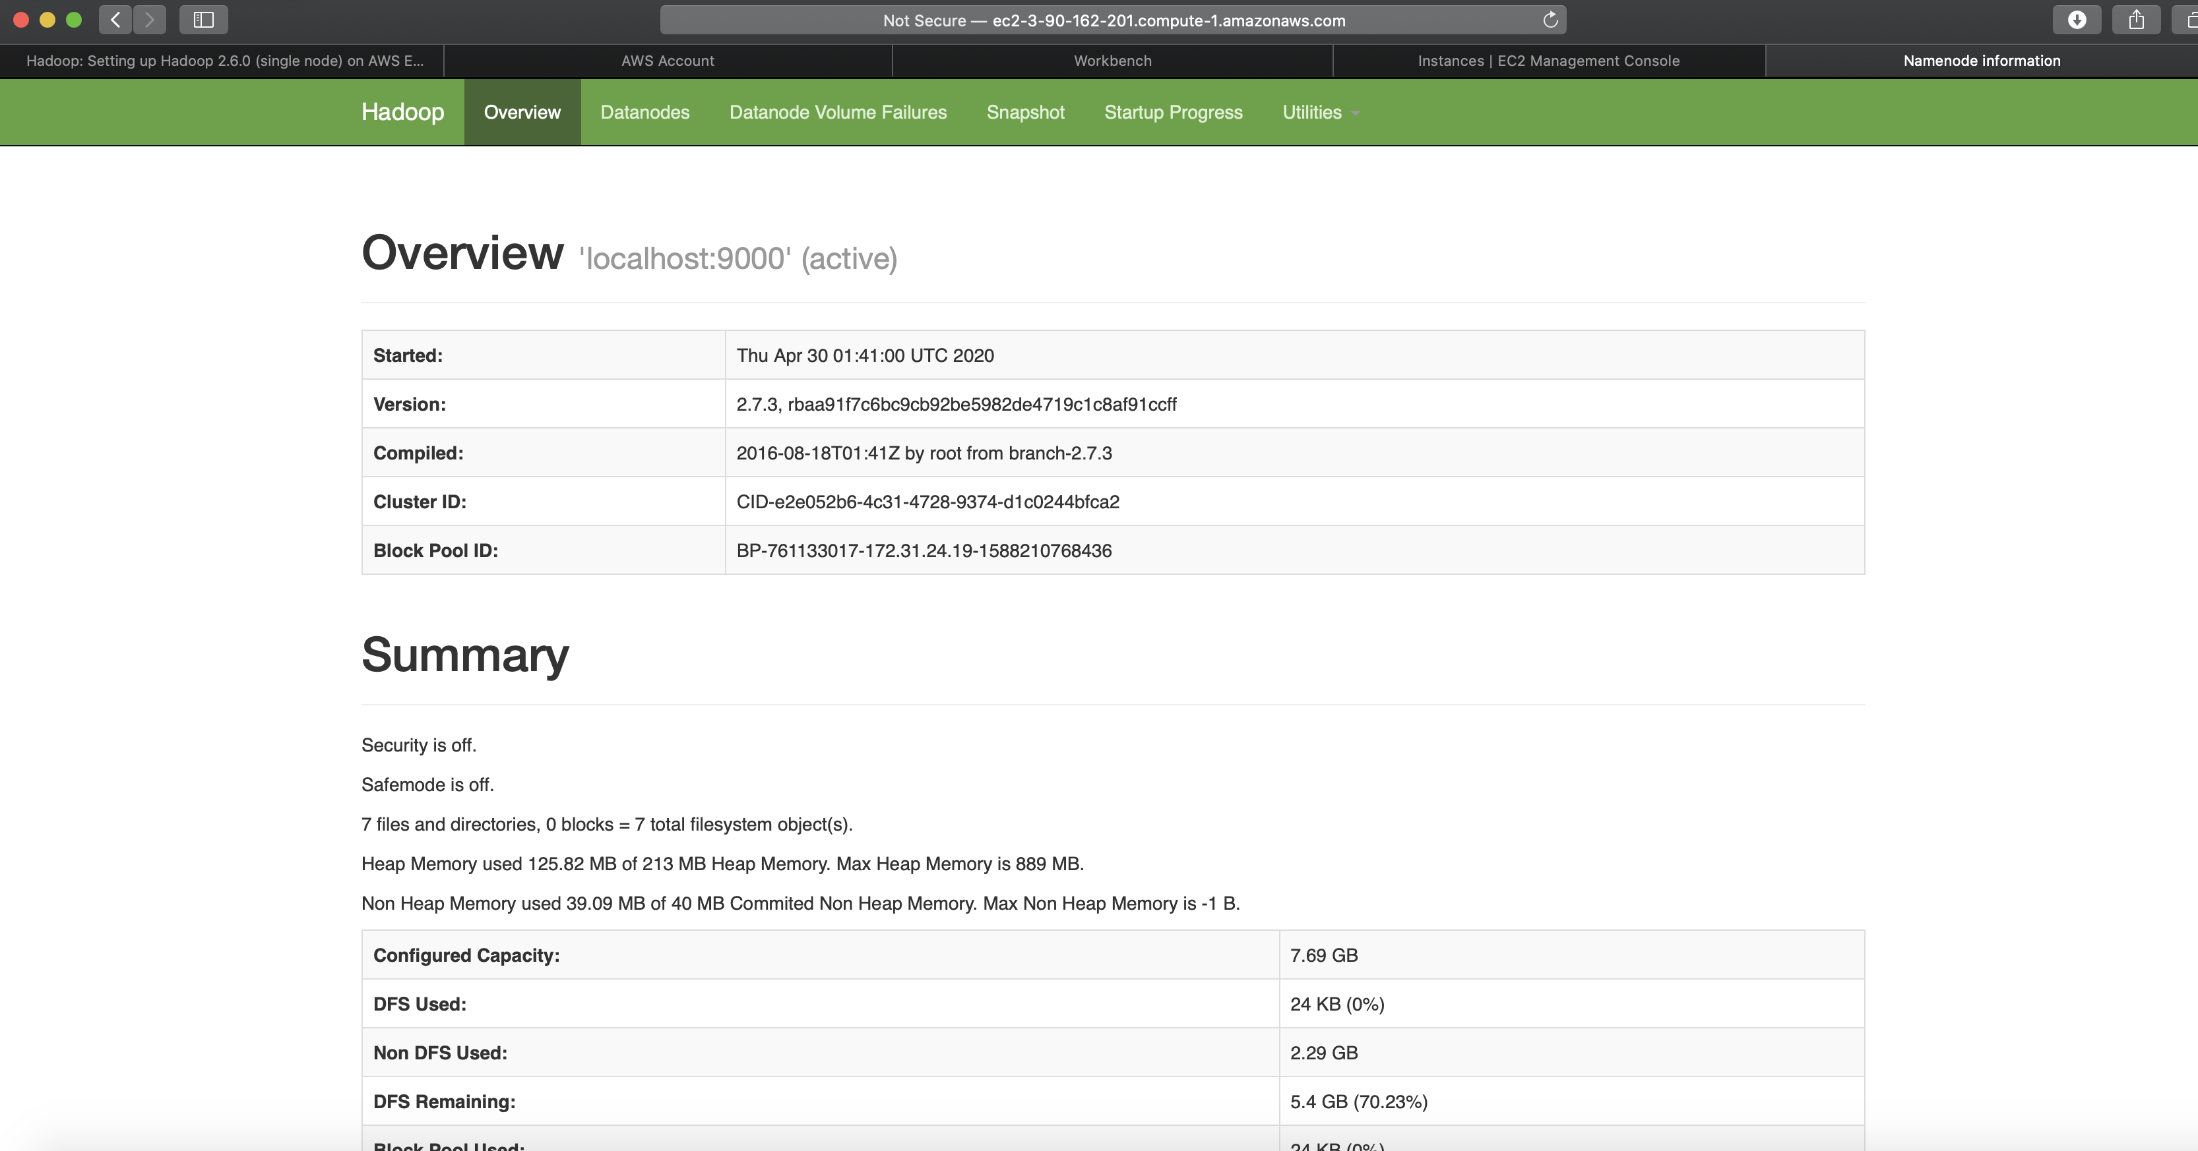

Making the input and output directories on the Hadoop file system,



Copying the *Pride and Prejudice* text file to the input directory on the Hadoop file system,



**MapReduce Modifications**

The WordCount.java class supplied by Apache Hadoop was modified to meet the needs of a bigram counter, namely, BigramCount.java. The Mapper of the BigramCount.java script below stores the previous and current String tokens in private globals, which is important since Hadoop is a distributed filesystem. As the list of input tokens are looped through, the previous and current String tokens are concatenated to form bigrams, which are in turn collected and mapped to the reducers.

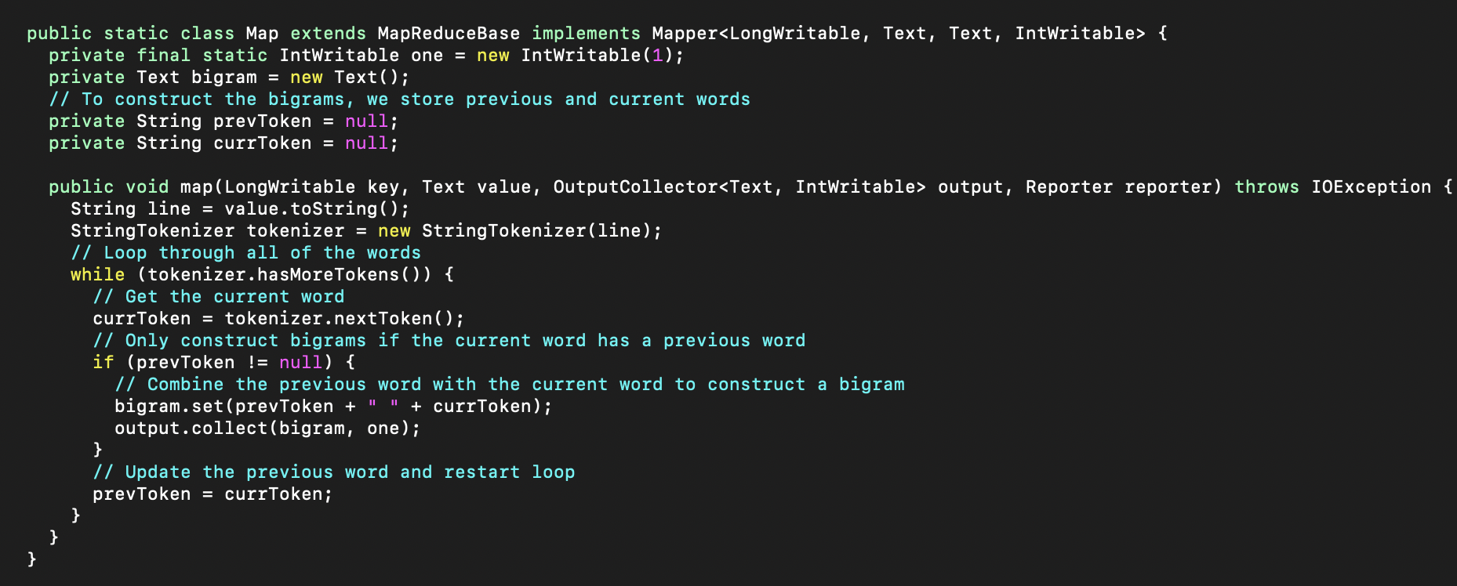

The Reducer supplied by Apache Hadoop did not need to be modified for this assignment,

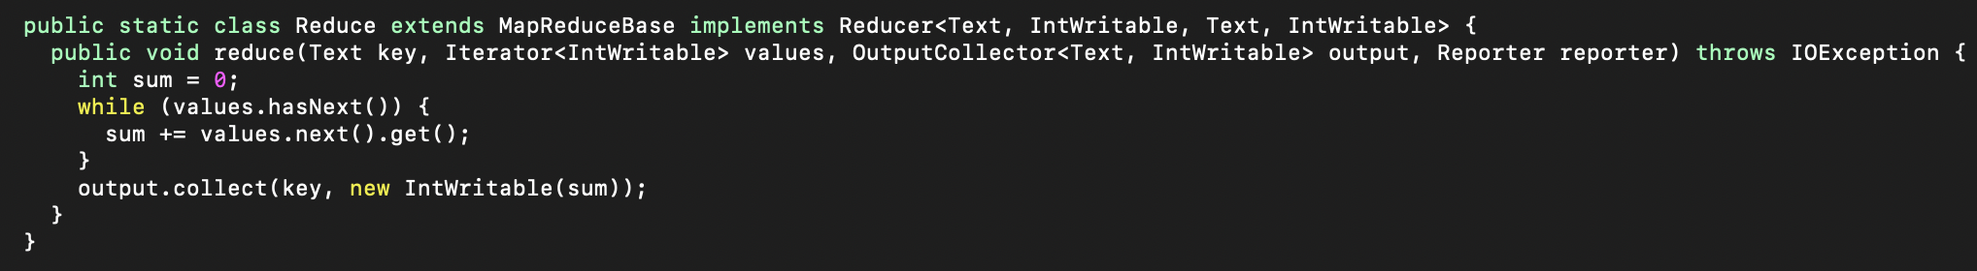

In addition, I set the number of reducers to 5 programmatically for our bigram counter, as seen below,

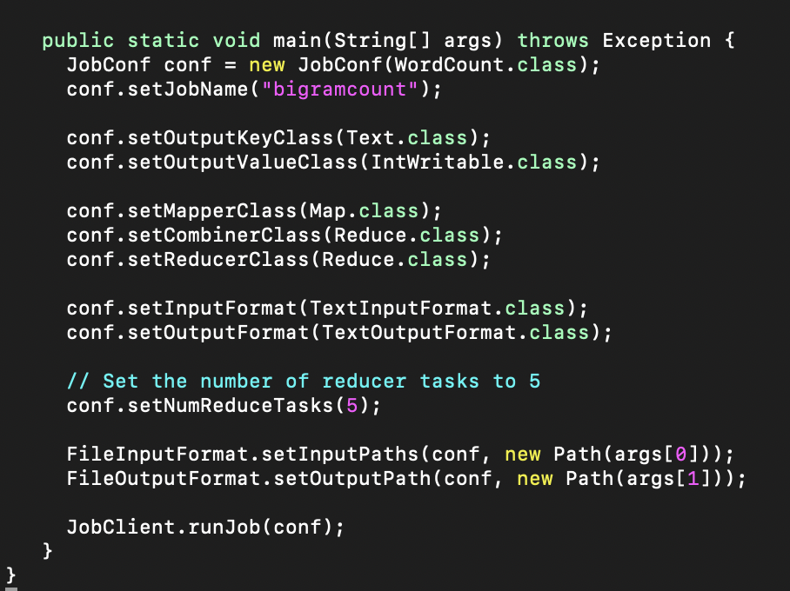

The main portion of this program is counting the bigrams from the *Pride and Prejudice* text file. In order to do this, we need to first compile out MapReduce program so that it can be run on Hadoop. Below, we can see the compilation of the BigramCount.java MapReduce program into class files in the BigramCountClasses directory,



Then we compile the BigramCount classes into BigramCount.jar, all seen below

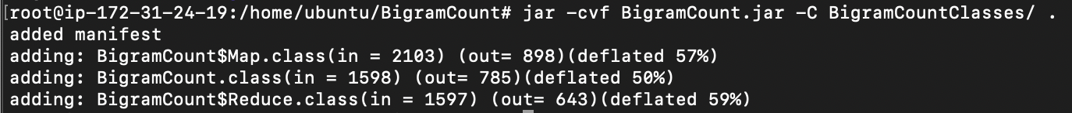

Next, we run the above generated BigramCount.jar on the Hadoop file system, as seen below,

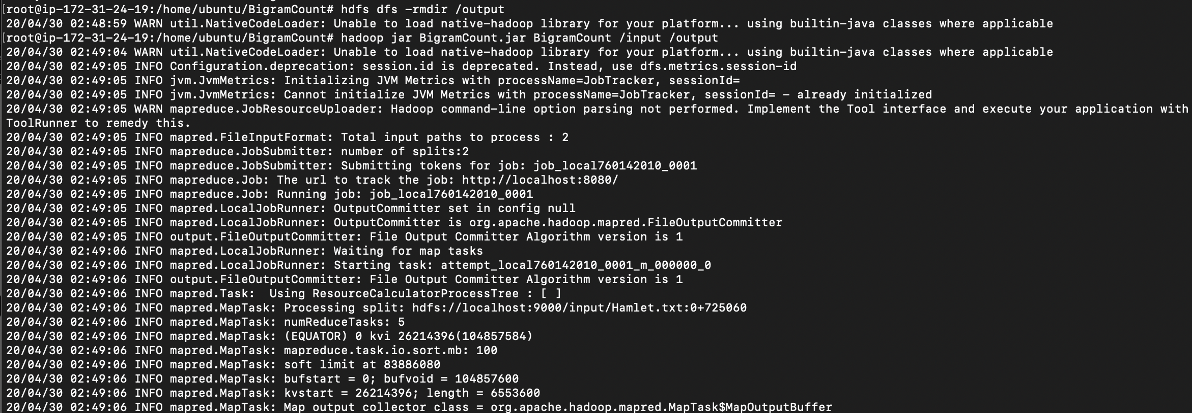

We were able to map and reduce the program!

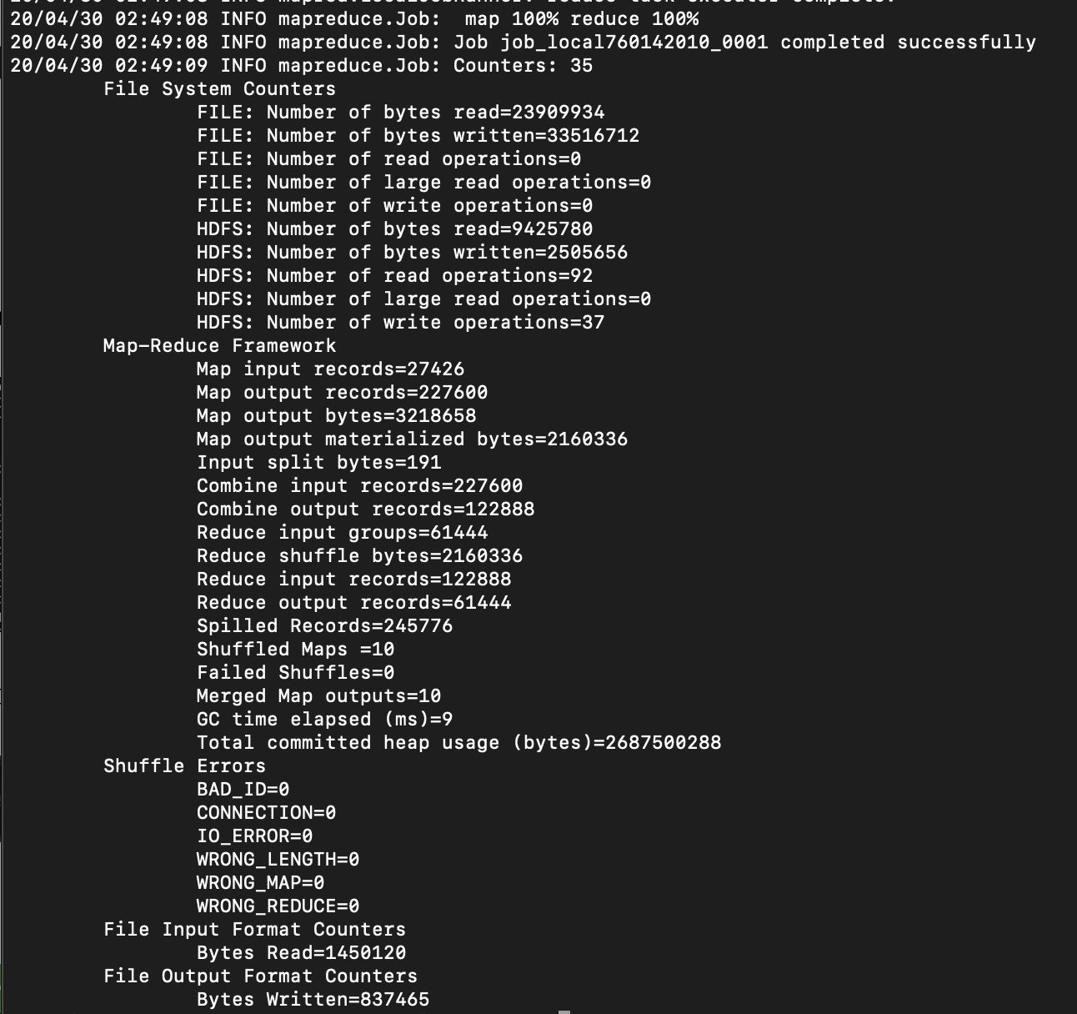

We can see the 5 output files in the Hadoop file system on the website, as seen below,

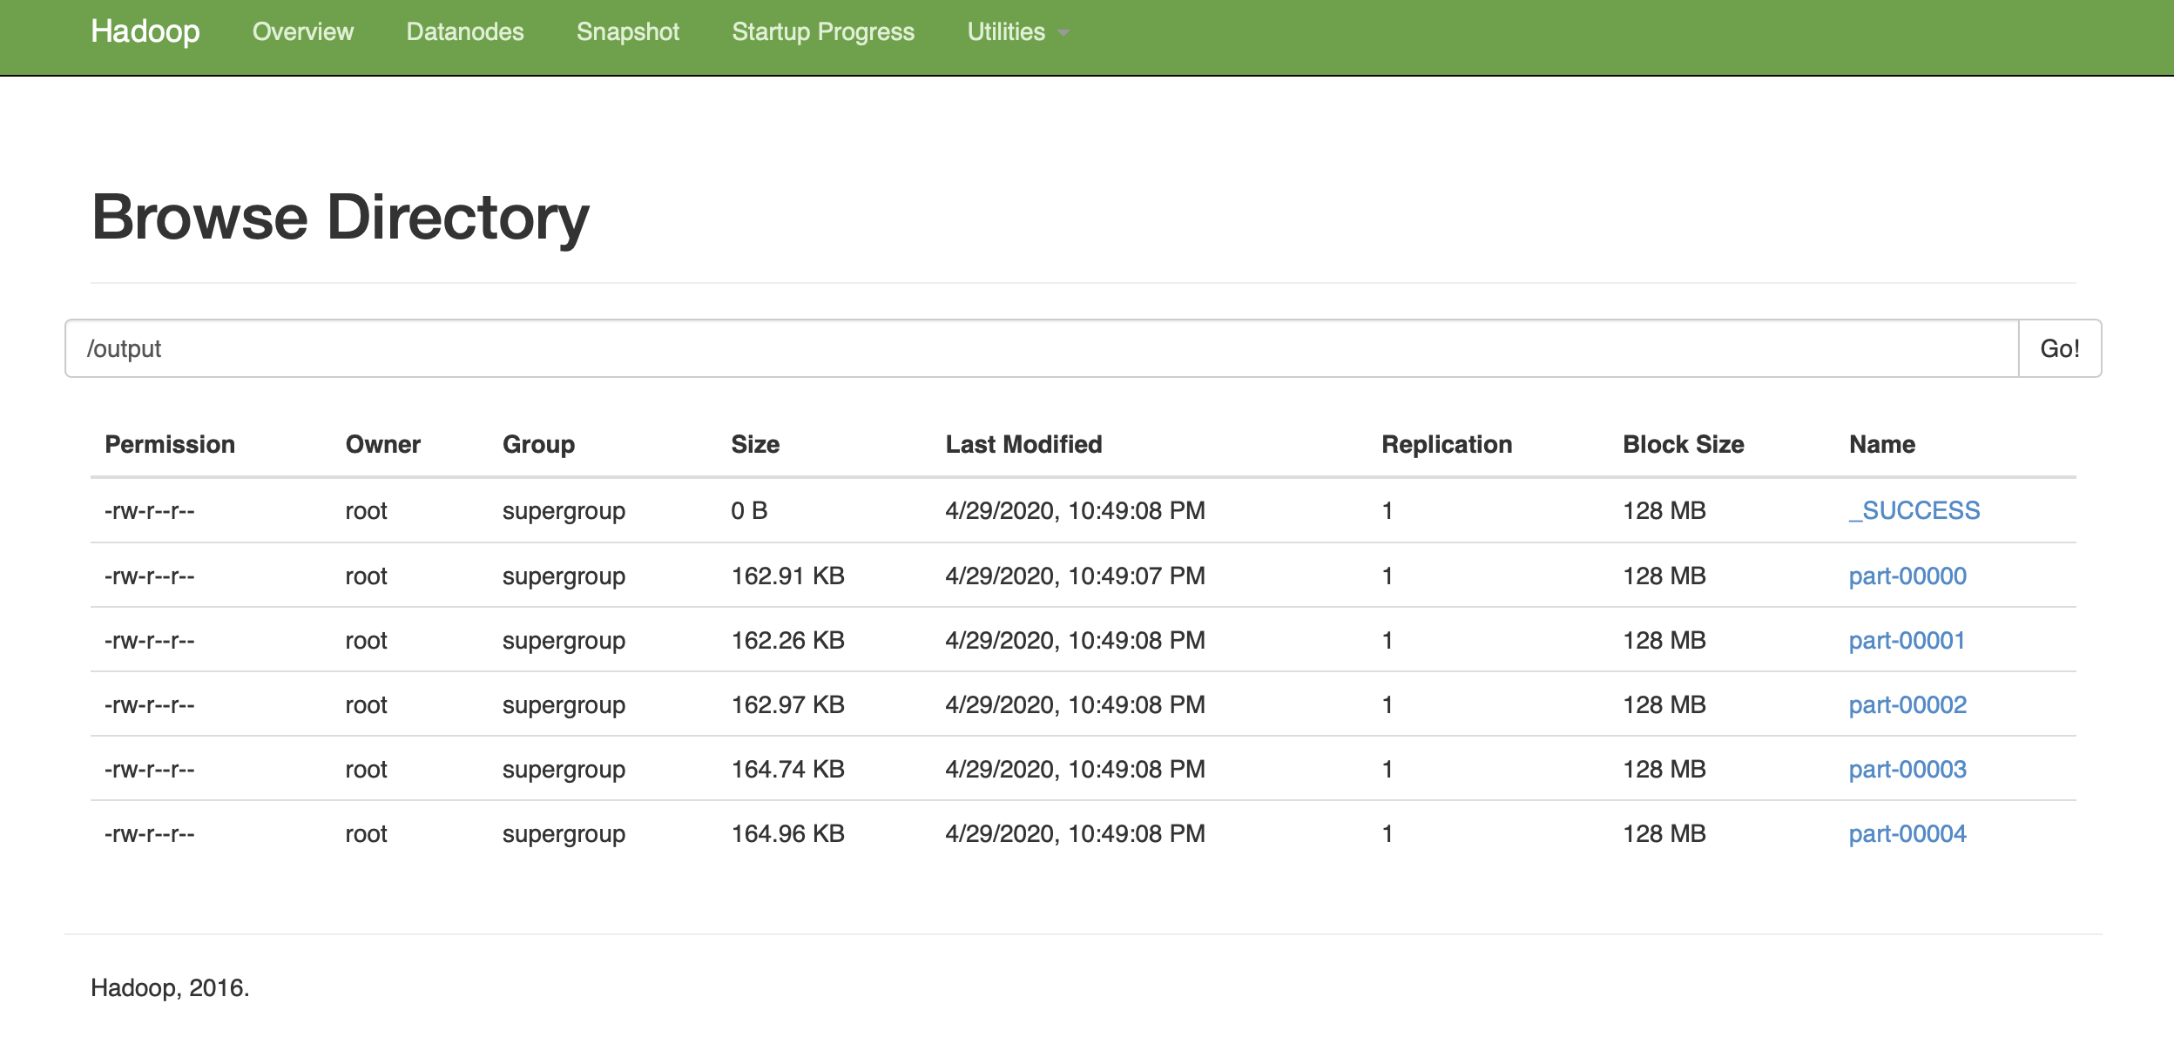

Next we get the output from the 5 reducers and store it locally, as seen below,



Then we use bash commands to concatenate all of the files into a single data stream, sort that steam alphabetically based on bigram text, and dump it into a single text file, as seen below,



Finally, we are finished with the Hadoop file system and can stop all processes,

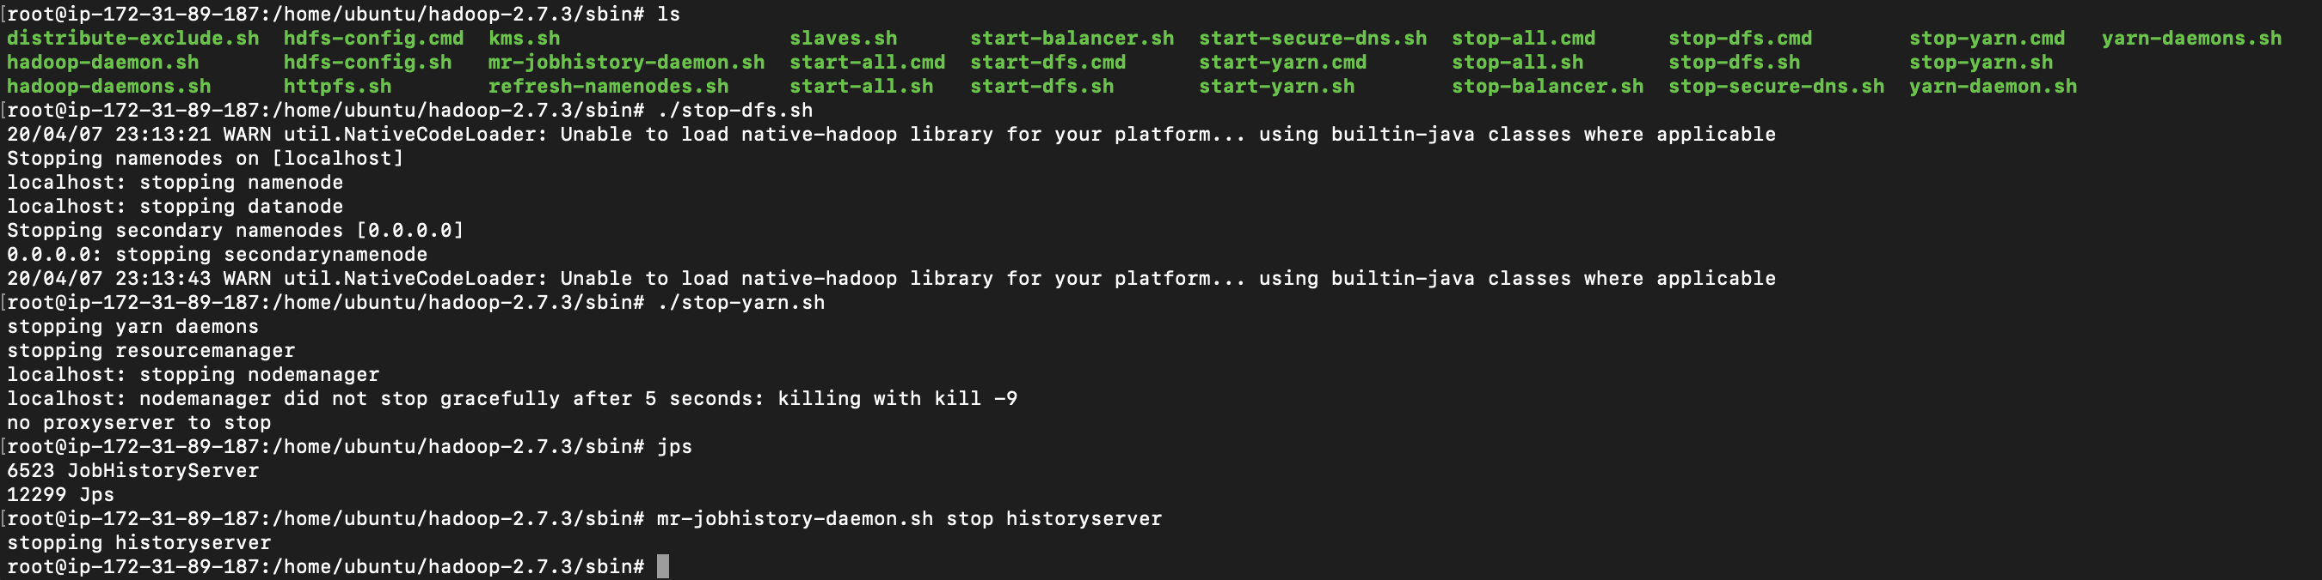

**Obtaining the Deliverables**

For simplicity, all of the deliverables are contained in a single Python script called BigramDeliverables.py. The individual outputs will be elaborated on the following pages, but this script can be seen in actions below,

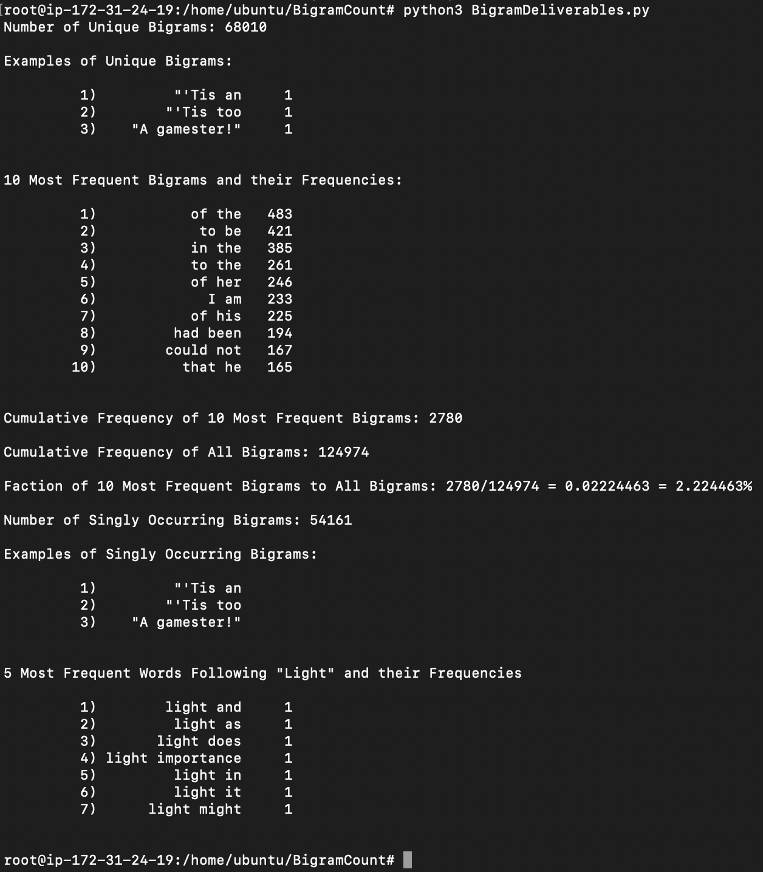

The first part of the BigramDeliverables.py script reads the data from the single concatenated output file into a dictionary with the keys as bigrams and the values as frequencies. This dictionary, bigram_counts, is used for all of the following deliverables.

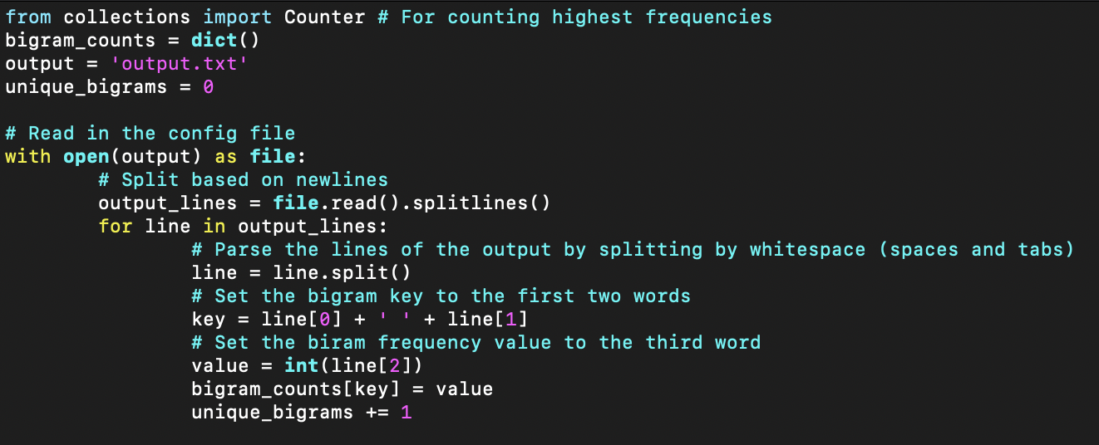

1. There are 68,010 unique bigrams. This can be verified since when we read in the file, all of the reducer outputs were already merged (since we only used a single mapper), therefore the number of lines in the file is equivalent to the number of unique bigrams. This counter is seen in the screenshot above, and can be verified in linux below,



1. 3 examples of unique bigrams are easily obtained below, (first three bigrams from the file)

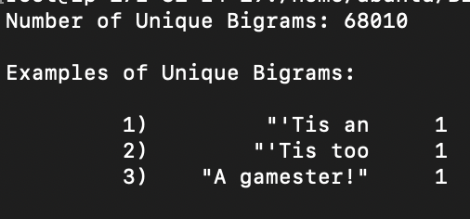

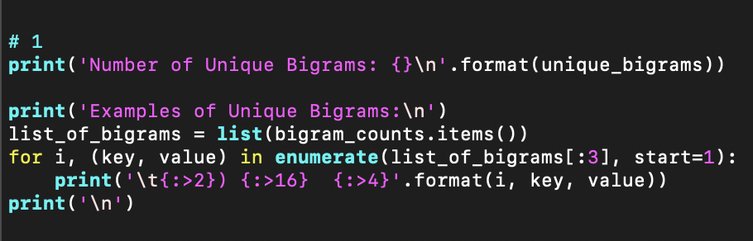

1. The top ten most frequent bigrams and their counts can be seen below,

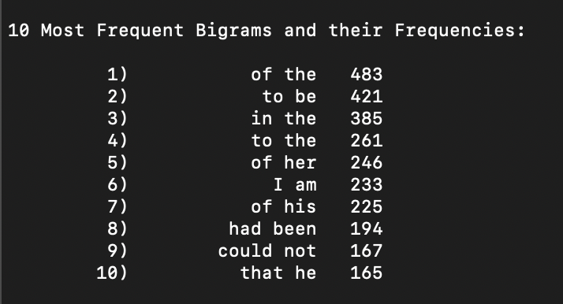

The Counter module is used to easily find the most frequent counts in this collection of bigrams and their frequencies. The bigram_counts dictionary is passed to the Counter constructor, and subsequently the most_common() method is called with parameter 10 to find the 10 bigrams with the highest frequencies.

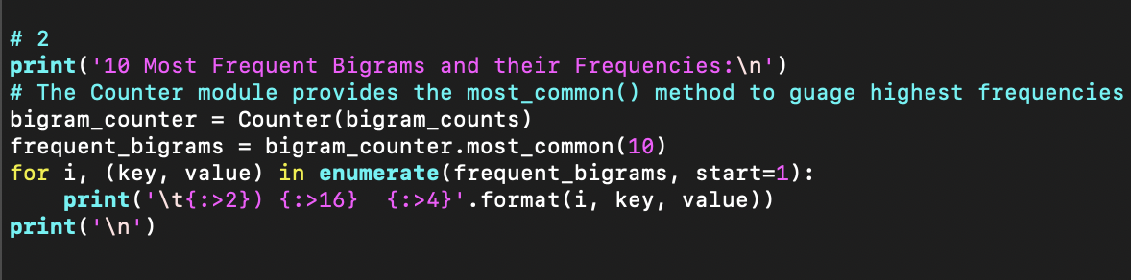

1. The bigrams with the 10 highest frequencies have a cumulative frequency of 2780. The cumulative frequency of all bigrams is 124974. Therefore, the ratio of the 10 most frequent bigrams to all bigrams is 2780/124,974 or equivalently 2.22 percent.

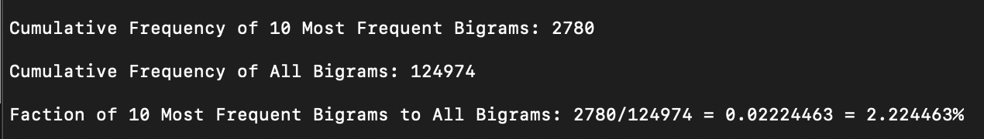

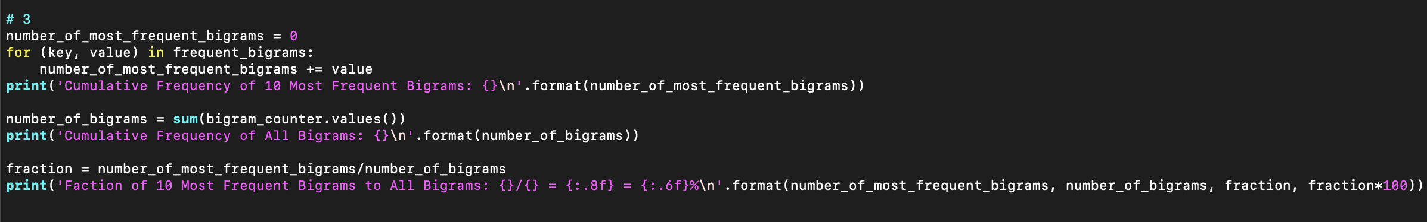

1. There are 54,161 bigrams that only appear once. This can be verified in the screenshot below. This number was obtained by looping through all bigrams in the bigram_counts dictionary and incrementing a counter for each bigram that had a frequency of 1.
2. The first 3 bigrams in the file suffice for this answer too, since they each only occur once.

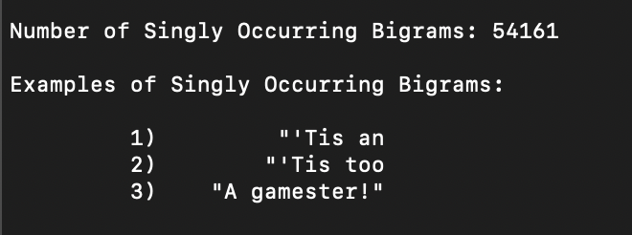

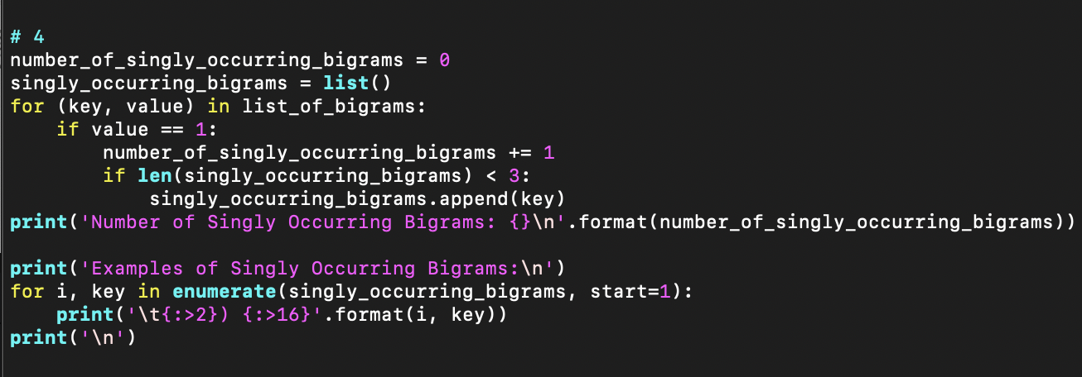

1. The five most frequent words following the word "light" did not make much sense in this context, because 7 words tied with once occurrence. Therefore, I listed all 7 of the bigrams that contained "light" followed by a word

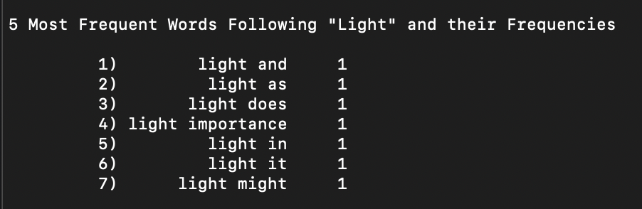

1. First, we create a dictionary light_bigrams to hold the bigrams containing "light" as the first word. Next, we convert the dictionary of all bigrams to a list of the contents of that dictionary. This will allow us to loop through the items easily. For each bigram in the list, split it using the split() function (and whitespace as a delimiter), and check if the first element of the resulting list is the word "light." If it is, then add this bigram and frequency as a key and value pair, respectively, to our light_bigrams dictionary. If it is not, then continue. Just as before, we invoke the Counter module to count the frequencies of the bigrams in the light_bigrams dictionary. The Counter module is used to easily find the most frequent counts in this collection of bigrams and their frequencies. The light_bigrams dictionary is passed to the Counter constructor, and subsequently the most_common() method is called to find the bigrams with the highest frequencies. It is observed there are 7 words with the frequency of 1, so we print them all.

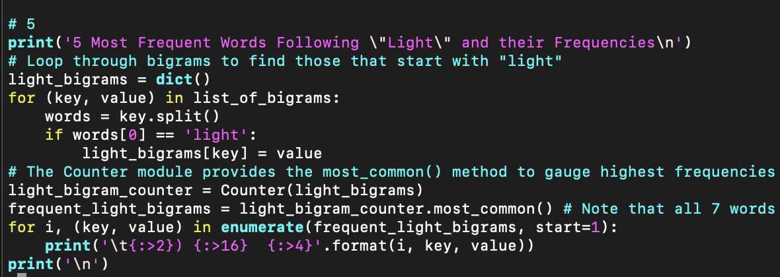

1. This assignment was completed on the cloud using an Ubuntu AWS EC2 Instance, as documented above.

**Part 2: Pandas**

For simplicity, all of the deliverables were again are contained in a single Python script, this time called explore_data_using_pandas.py. The individual outputs will be elaborated on the following pages, but this script can be seen in actions below,



1. Description of the data from my report:

For my final project, I created 6 web scrapers that collect information pertaining to government COVID-19-related emergency orders and stores them in CSV files. This collection of web scrapers uses the BeautifulSoup 4 and requests libraries in order to collect the text from each state in the New England region of the United States. After collecting the text, there are generally 3 elements of information that are scraped. These elements are:

1. Date, or the day that the measure was passed by the government.

2. Description, or the supplied summary of the measure.

3. PDF Link, or the source to the primary text the order.

These elements of information were available and scraped for all 6 of the states in the New England region. The csv files contain these attributes in their columns and the emergency orders in their rows, sorted from most recent to least recent date. Sometimes, more information was available. For example, Vermont and Massachusetts offered Press Release article links and Guidance links. I included these in their respective csv files.

In order to ensure consistency between files, the dates and descriptions had to be pre-processed. The dates were written in a variety of forms in the webpages. Using the datetime library, all of these dates were rewritten into mm/dd/yyyy format.

The descriptions generally needed more intricate processes to extract only the supplied text summaries for the government orders. A common theme across all of the government websites was inconsistent formatting, across both html tabs and the text within.

The inconsistent html tabs made me innovate solutions that rely less on positioning of tabs in the contents, and cater more to the relative structure of the contents. This approach is perhaps more robust to inconsistencies, but could still break if contents are rearranged.

The text was cleaned and pre-processed on a case-by-case basis. For example, the regex library was used for scraping Connecticut's website to eliminate excess spaces in the text. Many of the websites also needed their descriptions to be split to only include the description-associated text. For example, I was able to split off any text not related to the emergency order by looking for rare characters such as colons or parentheses, and breaking the text there. This will generally work, unless the website places one of these characters in the body of a summary.

I envision that this data will be able to be used to create useful features for deep learning algorithms, if enough data is scraped in consistent formats from all of the states.

1. The Pandas package is imported in the screenshot below,

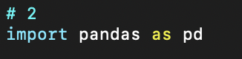

1. I scraped 6 state's government measures from their websites, so I loaded all 6 state's government measures into separate DataFrames using the read_csv() function. The output from head() is also displayed below,

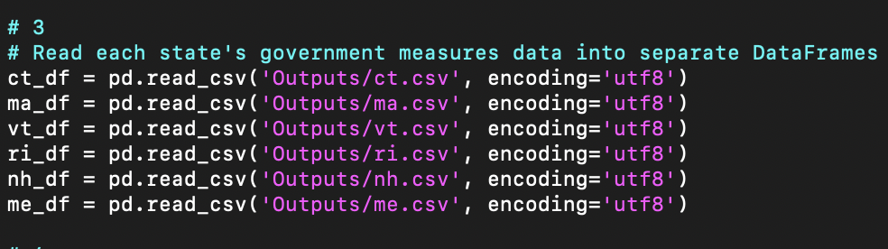

In the head() outputs below, we can see that most of the websites scraped had dates, descriptions, and PDF links. Massachusetts and Vermont also offered press release links and guidance links.

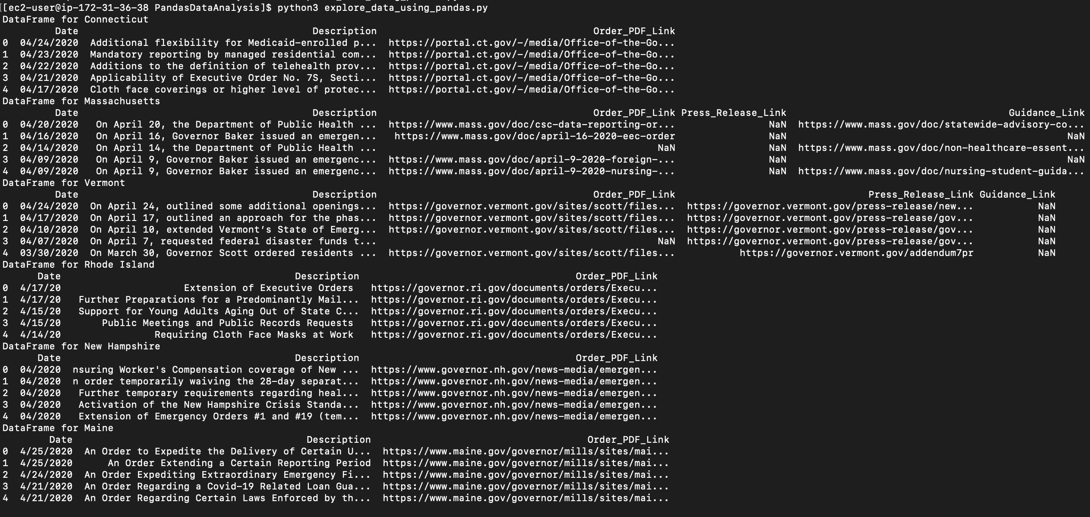

1. The data types for each column in each DataFrame can be seen below. All of the data is Strings, which are represented as objects by Pandas. Most of the websites scraped had dates, descriptions, and PDF links. Massachusetts and Vermont also offered press release links and guidance links.

|  |  |
| --- | --- |
|  |  |

1. Sorting by the column 'Date', which consists of the dates that the government measures were passed. The top 15 entries are indicated below in descending order.

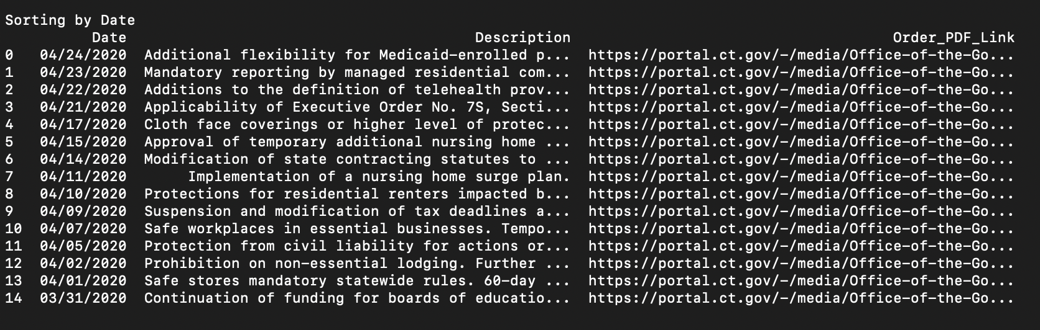

The sort_values() function with the 'Date' column passed as parameter will sort based dates. The ascending parameter is set to False so that the dates are given in descending order. The head() function with a parameter of 15 gives the first 15 entries in the resulting DataFrame,

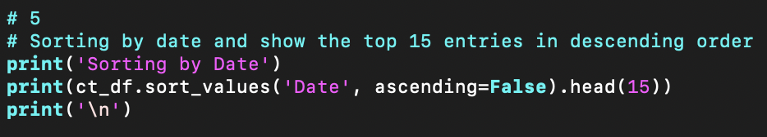

1. Horizontal and Vertical Filtering
2. Horizontal filtering by selecting the 'Date' and 'Description' columns, which consist of the dates that the government measures were passed and the summaries of those government measures, respectively, and leaving out the column 'Order_PDF_Link', which consists of the links to the source text of the government measure. The top 15 entries are indicated below in descending order.

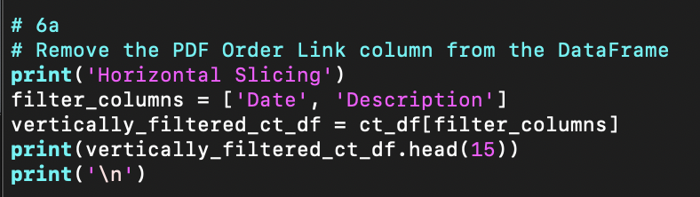

The orders are displayed in descending order since their dates are from most recent to least recent. Only the "Date" and "Description" columns are seen, confirming our horizontal filter.

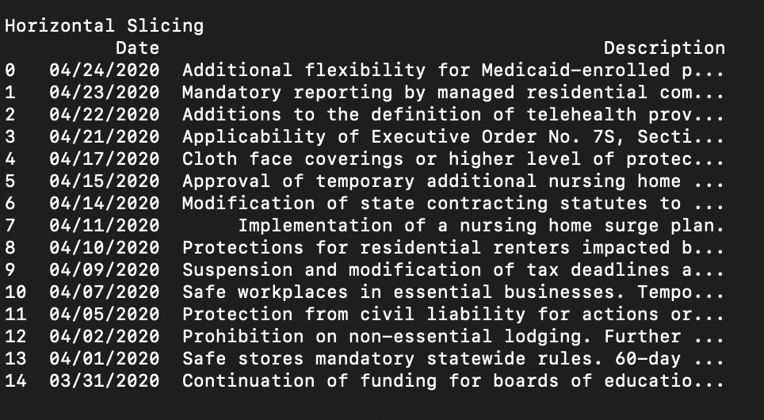

1. Vertical filtering by selecting the rows with dates that are before "03/31/2020". The top 15 entries are indicated below in descending order.

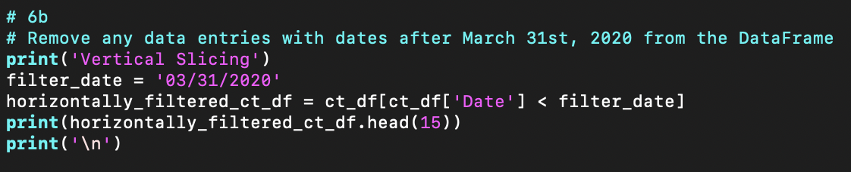

The orders are displayed in descending order since their dates are from most recent to least recent. Only dates before "03/31/2020" are seen, confirming our vertical filter.

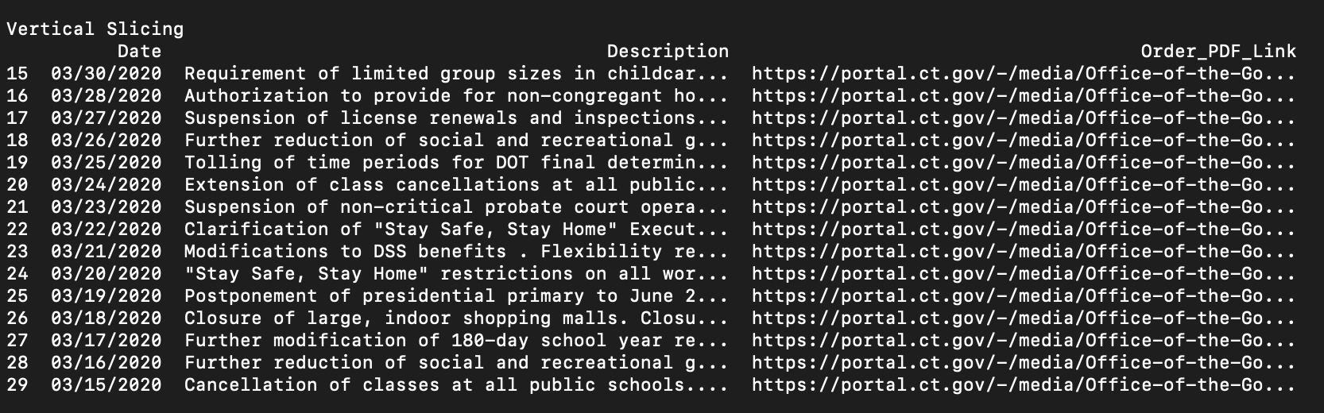

1. Here, we merged 2 DataFrames in 2 different ways. First, we merged Connecticut's and Vermont's DataFrames using an "Outer" merge, then we merged them using a "Left" merge. I thought that these would be interesting DataFrames to merge because Vermont is one of the files that had extra columns of data. Let's examine the merges individually below,

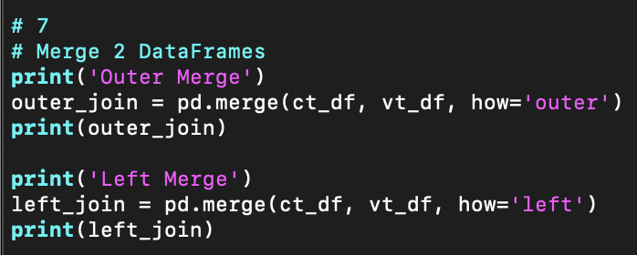

The "Outer" merge completely combines the rows of each DataFrame. Since both DataFrames had the "Date", "Description", and "PDF_Order_Link" columns in common, the data stacks up very neatly for the most part. However, Vermont introduces two new attributes in this merged DataFrame, namely "Press_Release_Link" and "Guidance_Link". Since Connecticut did not have data for any of these fields, the DataFrame marks these valued as "NaN." On another note, Connecticut did not always provide these fields, so sometimes it has "NaNs" in thse fields too.

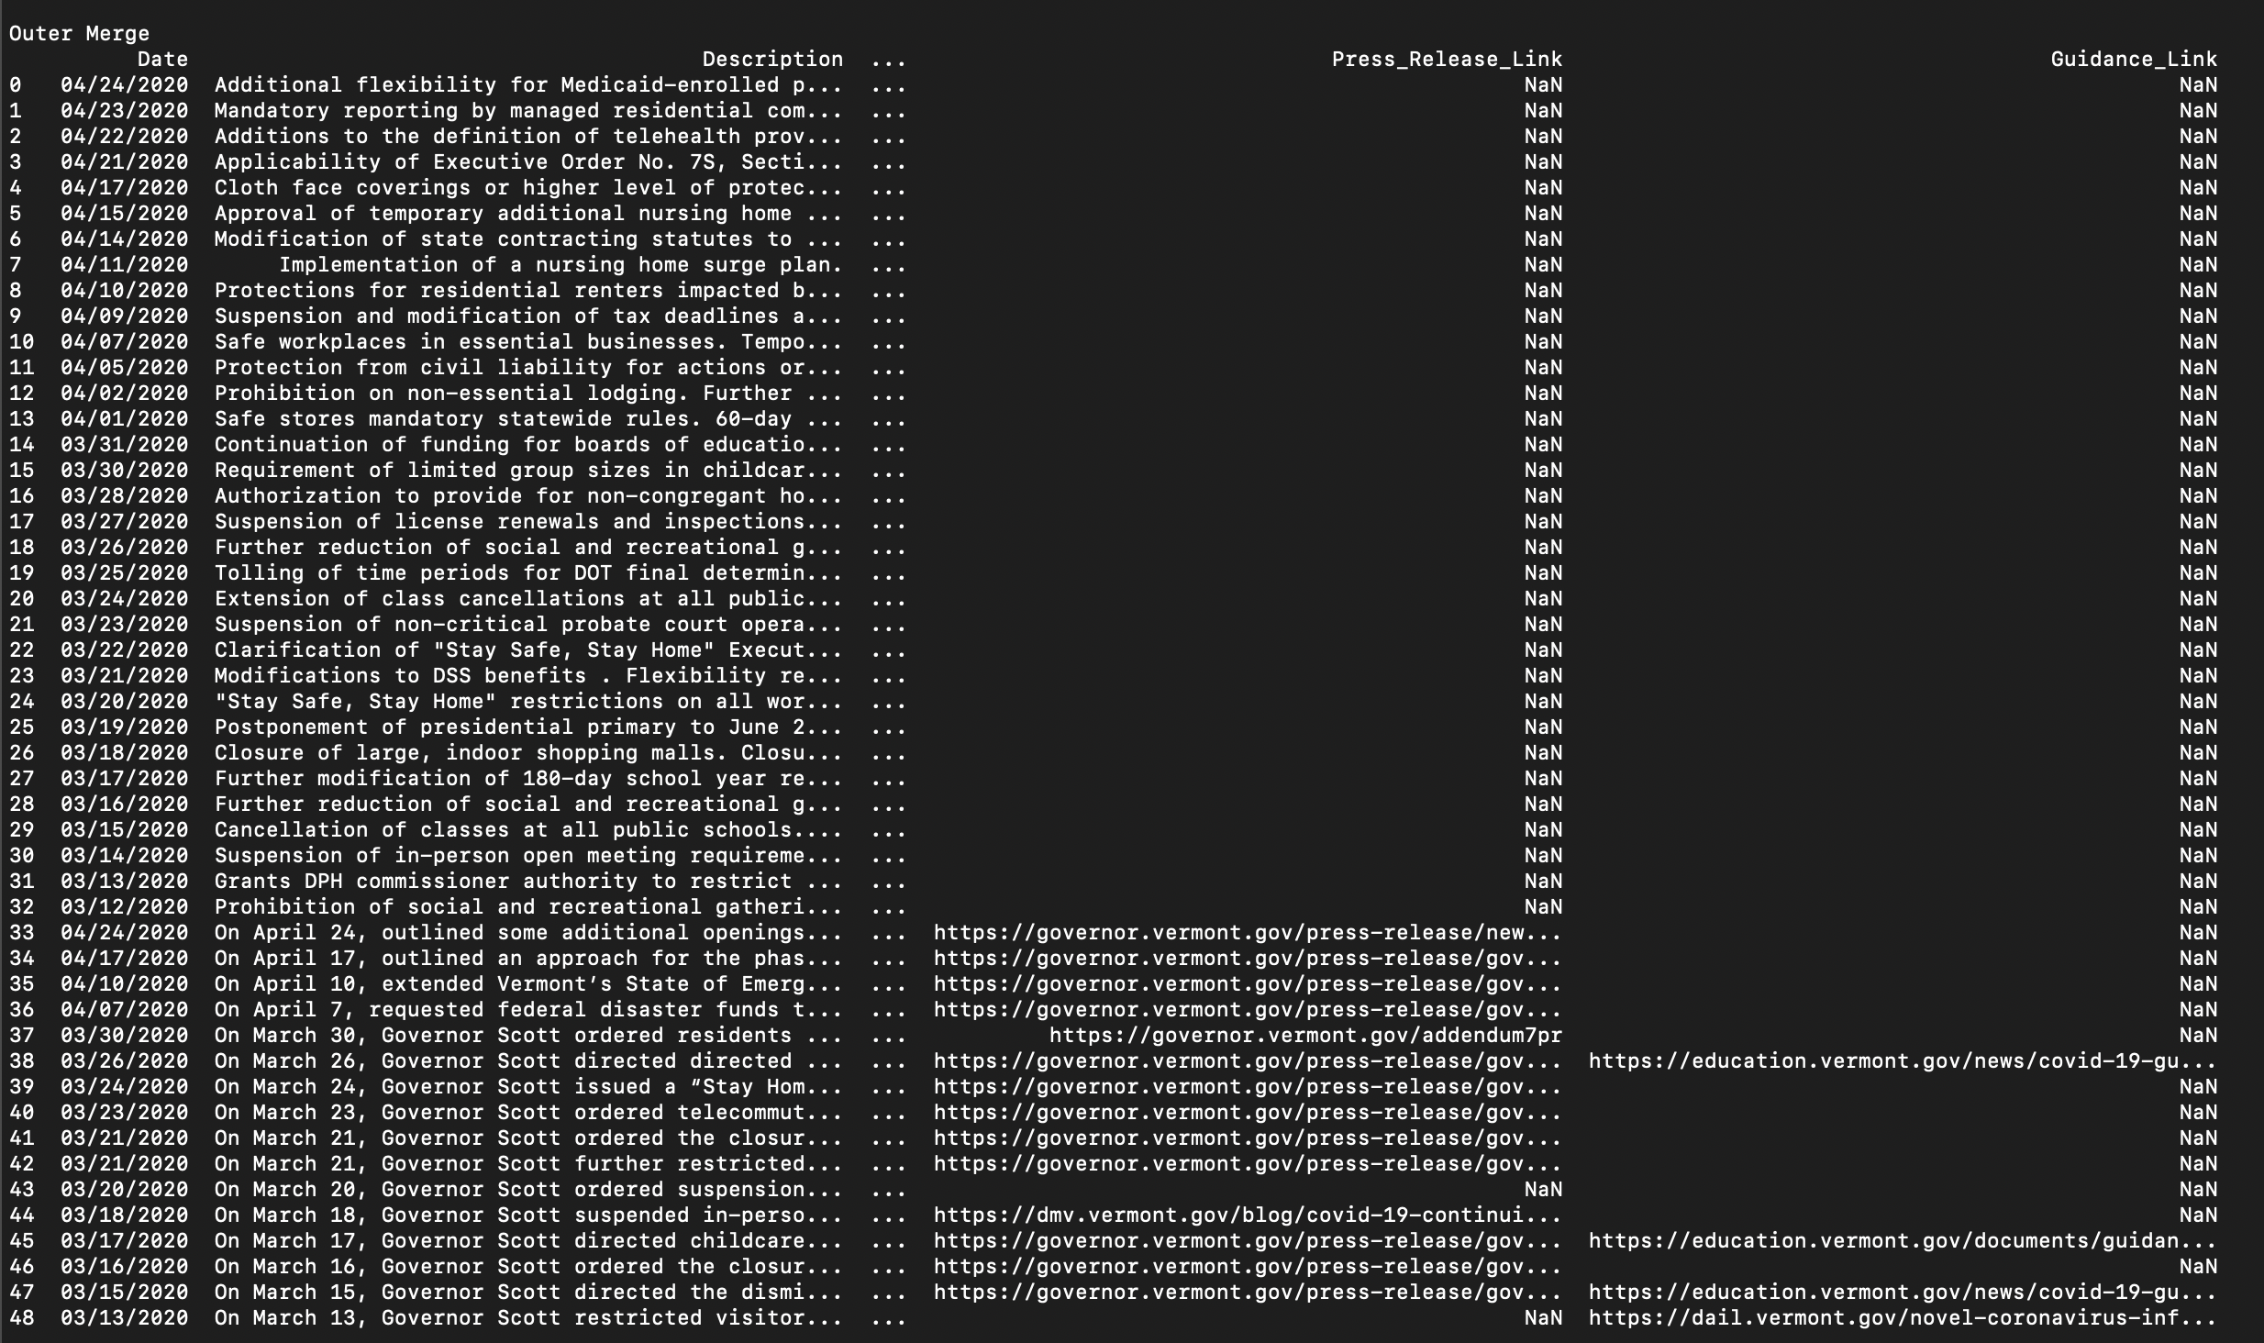

The "Left" merge completely overlays the data in the left parmater into the right parameter. Since both DataFrames had the "Date", "Description", and "PDF_Order_Link" columns in common, but Connecticut has every date that Vermont has, and more, Connecticut ends up overwriting all of Vermont's data in this merged DataFrame. However, Vermont introduces two new attributes in this merged DataFrame, namely "Press_Release_Link" and "Guidance_Link". Since Connecticut did not have data for any of these fields, the DataFrame marks these valued as "NaN."

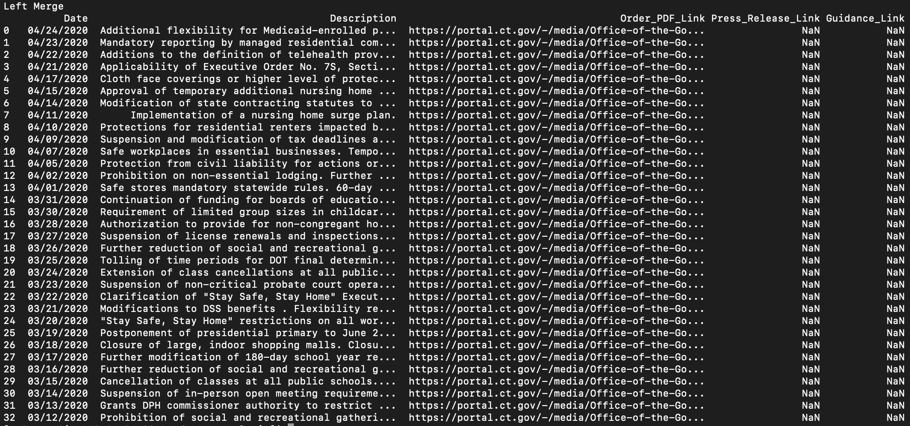

1. Finally, we export the merged DataFrames to JSON files.

